A C ORD• CERTIFICATE OF LIABILITY INSURANCE I DATE (MM/00/YYYY)
10/25/2008
~
PRODUCER THIS CERTIFICATE IS ISSUED AS A I\MTTER OF INFORI\MTION ONLY
AND CONFERS NO RIGHTS UPON THE CERTIFICATE HOLDER. THIS
InsumceAgent/BrokerName
CERTIFICATE DOES NOT AIVEND, EXTEND OR ALTER THE
InsumceAgent/BrokerStreet Address orP. 0. Box
COVERAGE AFFORDED BYTHE POLICIES BELOW.
InsumceAgent/BrokerCity, State & Zip Code
Contact & Phone Number
INSURERS AFFORDING COVERAGE NAIC II
INSURED INSURER A Name ofInsurance Company EnterNAIC#
Marina/Facility OwnerNlme Street INSURER B: Name ofInsurance Company(ifapplicable) EnterNAIC#
Principle Address orP.0. Box INSURER C: Name ofInsurance Company(ifapplicable) EnterNAIC#
City, State & Zip Code INSURER D: Name ofInsurance Company(ifapplicable) EnterNAIC#
INSURER E: Name ofInsurance Company(ifapplicable) EnterNAIC#
COVERAGES
THE POLICIES OF INSURANCE LISTED BELOW HAVE BEEN ISSUED TO THE INSURED NA.MEDABOVE FOR THE POLICY PERIOD INDICATED. NOTWITHSTANDING
ANY REQUIREMENT, TERM OR CONDITION OF ANY CONTRACT OR OTHER DOCUMENT WITH RESPECT TO WHIC,H THIS CERTIFICATE MAY BE ISSUED OR MAY
PERTAIN, THE INSURANCE AFFORDED BY THE POLICIES DESCRIBED HEREIN IS SUBJECT TO ALLTHE TERMS, EXC':j'-ONS AND CONDITIONS OF SUCH
POLICIES. AGGREGATE UMITS SHOWN MAY HAVE BEEN REDUCED BY PAID CLAIMS.
NSR A00·1 POL ICY EFFECTIVE POLICY EXPIRATION "'­
LTR INSR TYPE OF INSURANCE POLICY NUMBER DATE f MM/00/YYl DATE fMMID 0/YYl LIMITS
•
A ~ GENERAL L IAB ILIT Y 90MA0045 -0 12/19/08 04/23/10 / EACFhOC CUR ~t{c E, $1,000,000
~ COMMERICAL GENERAL LIABILITY ~:~~~}~~~~~J!~ence) $100,000
DoD_ CLA JMSMADE ~OCCUR MED eXP (An} o_[le person)~ $Excluded
PERSONAL&~ DV' INJ_U,>f $1,000,000
~Marira Liability ~ GEN ERAk AGG REGATE $2,000,000
GEN'L AGGREGATE LIMIT APPLIES PER: -- .
PRoouctS(. cdMP,oP AGG $!,000,000
D POLlcYD PROJEcTD LDC )
$
..,
'
B IZI AUTOMOBILE LIABILITY 4146366600 07/31/09/ - --.. P'"" COM~JNED SIN GL.E LIMIT $3,000,000
'~ ANY AUTO ' (E~cl'l Occurrence)
D ALLOWNEOAUTOS J BODILY INJURY $
(Per person)
gD S CHEDULED AUTOS
j~ ."..
HIRED AUTOS ~-OD ILY INJ~RY $
I=...., i =a~1iti;s·th~t·d~ ~ot o~;e~ ;ndl~r ~p~r~t; ;uio:n~bhe; ~n s,ie" sho~Jd ;u£v.r;,J aietfe;, ;t;ti~g'th~t a~t~,;,obik:Js·a;e~ ~t" . .
,= . $
i-owned or ooerated bl the facilitv. .
....... ... I. .. t. ... t. ... t. .t. t..l.1.t.&.t. .L & t.&.t.&..1, 1. .Lt..t. • •a. 1 .t.t. t. .L&t. •• a..1,1.a.1. .1. .1,1. •• .t. a.
GARAGE L IAB ILIT Y AU TO ONLY· EAACCID ENT $
D D ANY AUTO A~ ~ OTHER THAN EAACC $
D_ AUTO ONLY: AGO $
· ~
EXCESS/UMBRELLA L IAB IUT Y EACH DC CURRENCE $
D D OCCUR D CLAIMS MADE '7' AGGREGATE $
$
D OED UCTIBLE I~~ $
D RETENTION $__ A ~~~··" $
C ~ W EM O P R L K O E Y R E S R C S O ' L M IA P S E N IL S IT A Y T , lciN'AND 10/25/2008 10/25/2009 ~ T W O C R S Y T L A IM T I U T · S DOT E H R ·
J ~ANY PR QPR IETORil1ARTNER/EXEC U· E.L. EACH ACCIDENT $1,000,000
TIVE Of' f'ICER/MEMBER EXCLUDED?
If yes, describe uncle{ -- E.L. DISEASE· EAEMPLOYEE $1,000,000
\SPECIAL PR OVISI~ S belON _-­ .... .. E.L DISE.AS.E · P.OL.IC.YL.IM IT $1,000,000
. ,
~. ,,.,, . ,,, , ,, . ,, . ,,, , ,, ., , , , ,, ,., , , ., , ,
D F.a.ci li.tie.s .e m.p .loy.in.g. fe.w e.r .th an. 4 .e mp.lo.ye.e.s n.ee.d. t o co.m.p.let.e .an.d .su.b.m.it a . W .or.l< e.rs. C.o m.p.e n.s.a t.ion. E.x e.m.p.tio.n .F o.rm. . . 1
, , , ~
" I I I I
DESCRIPTION OF OPERATIONS/LOCATIONS/ "'IEH IC LES I EXCLUSIONS ADD ED BY ENDORSEMENT I SPECIAL PROVISIONS
Marira, restaurant, ~ft shop
Marina/FacilityNlme
Physical Street Address
City, State Zip
CERTIFICATE HOLDER CANCELLATION
SH OU LO ANY OF THE ABOVE O ESCR 18 ED POLICIES BE CANCELLED BEFORE THE
Florida Department ofEnvirormental Protection
3 T 9 a 0 lla 0 h C as o s m ee m , o F n L w 3 e 2 a 3 lt 9 h 9 B -3 lv 0 d 0 . 0 0 E M X A P IL IR 3 A 0 T I D O A N Y O S A W T R E I T TT H E E N R E N O O F T , I C T E H E T O IN T S H U E R E C R E R AF TI F F O IC R A D T I E N G H O C L O D V E E R R A N G AM E E W D I L T L O E T N H O E E L A E V F O T R , B T U 0 T
FAILURE TO DO SO SHALL IMPOSE NO OBLIGATION OR LIABILITY OF ANY KIN O UPON THE
INSURER, ITS AGENTS OR REPRESENTATIVES.
AUTHOR 12 ED REPRESENTATIVE
ACORD 25 (2001/08) ©ACORD CORPORATION 1988

Drawing/Layout Snapshot - Page 1
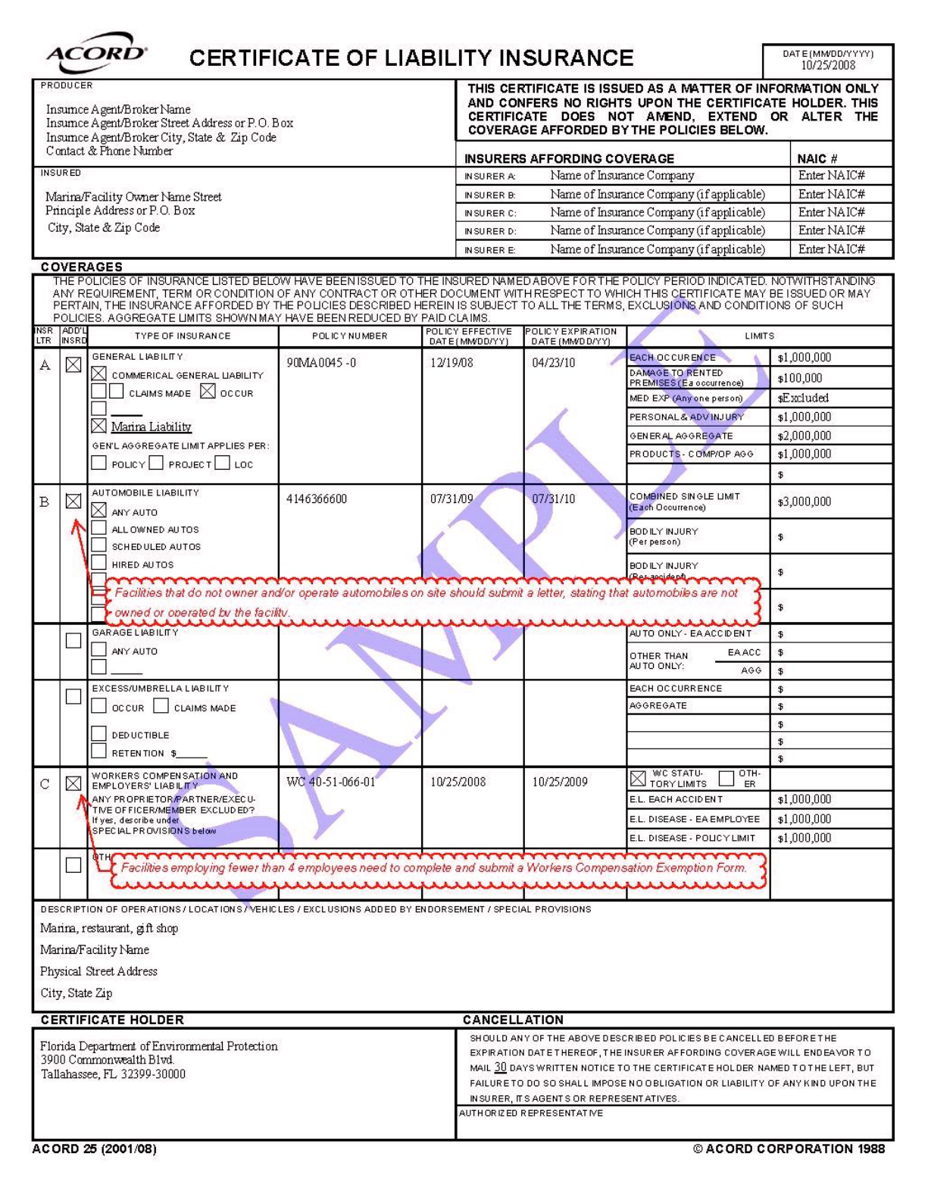

IMPORTANT
If the certificate holder is an ADDITIONAL INSURED, the policy(ies) must be endorsed. A statement on this
certificate does not confer rights to the certificate holder in lieu of such endorsement(s).
If SUBROGATION IS WAIVED, subject to the terms and conditions of the policy, certain BOlieies may require an
endorsement. A statement on this certificate does not confer rights to the certificate holder in lieu of such
endorsement(s).
DISCLAIMER
The Certificate of Insurance on the reverse side of this form does not constitute a contact between the issuing
y
insurer(s), authorized representative or producer, and the cepificate holder, nor ~~es it7 atively or negatively
amead, extead oc altec the co,ecage affocded by the polide listed theceoa.
ACORD 25 (2001/08)

Drawing/Layout Snapshot - Page 2
